**Louisville Office of Research and Innovation**

**Written by: Cardinal Strategic Development Team**

Queena Lin

Isaac Mills

Hasan Mohammad

Trey Sledge

Durian Spagnuolo

Dean Stitt

**Iteration 5 Deliverable**



**Table of Contents**

Class Diagram

Database Design

Navigation System

Screen Layout

Gantt Chart

Prototype

**Class Diagram**

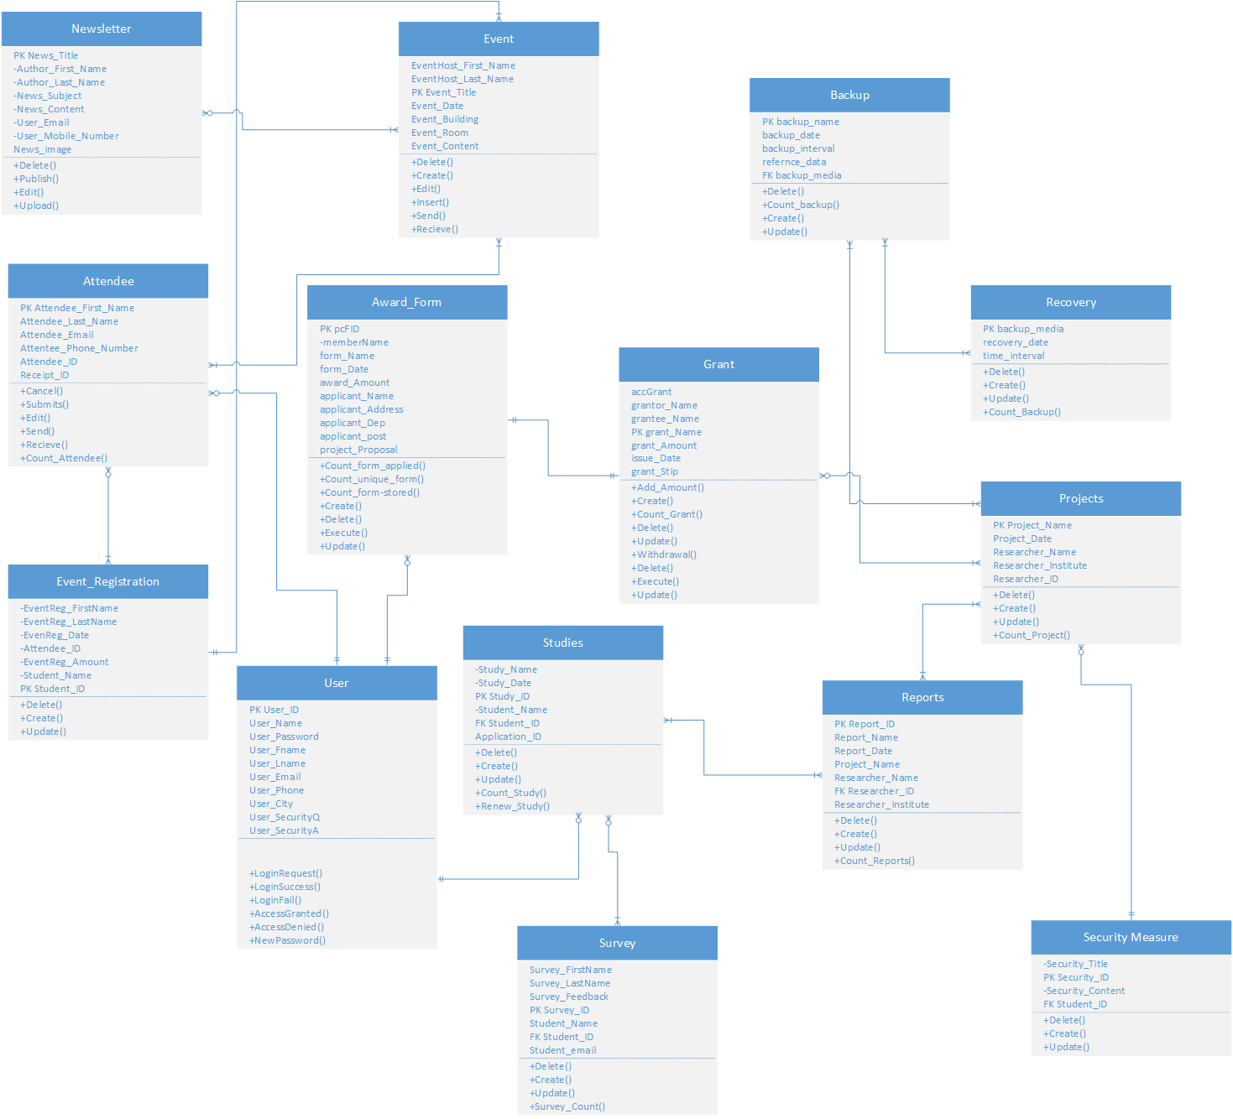

This class diagram shows the relationship between different classes for the necessary entity for the operation of the Research & Innovation Center. The above shows both the entity relation in terms of one case and in many cases. For instance, users may register for events and need to create an attendee for the event. This dependency is shown above and details the methods that will need to be created to ensure the user requirements are met. Attributes are shown to give the developer the names of variables that will be required to meet the needs of the prototype and finished product.

|  |  |
| --- | --- |
| Class - Newsletters | |
| Responsibility   * Know who published the letter * Know who edited the letter * Know who uploaded new letters * Allow users to read letter * Allow the user to sign-up for weekly newsletter * Allow the user to opt-out of the weekly newsletter | Collaborator   * Event |

|  |  |
| --- | --- |
| Class - Attendee | |
| Responsibility   * Allow user to cancel * Allow user to edit attendee * Allow user to submit attendee * Allow users to send and receive information * Know the count of the attendees | Collaborator   * Event * Event Registration |

|  |  |
| --- | --- |
| Class - Event_Registation | |
| Responsibility   * Allow user to create registration * Allow user to delete registration * Allow user to update registration | Collaborator   * Event * Attendee |

|  |  |
| --- | --- |
| Class - Survey | |
| Responsibility   * Allow the user to create a form * Allow the user to edit form * Allow the user to delete form * Ask questions related to particular studies * The user is expected to provide feedback | Collaborator   * studies |

|  |  |
| --- | --- |
| Class - Event | |
| Responsibility   * Description of the event location, session ID, date, and host * The user creates an event * The user edits an event * The user deletes an event | Collaborator   * Event Registration * Attendee |

|  |  |
| --- | --- |
| Class – Award_Form | |
| Responsibility   * Display information on related grants or reward * The applicant provides name, address, and ID * The user can create an award form * The user can edit an award form * The user can delete an award form | Collaborator   * Grant * Study * Project |

|  |  |
| --- | --- |
| Class - Studies | |
| Responsibility   * Provide a description of information of particular study that the user applied for * Connect the user information with the related study * Provide excesses link to regarding the studies * The user can create a study * The user can edit a study * The user can delete a study * The user can renew or extend the study period | Collaborator   * Grant * Study * Project |

|  |  |
| --- | --- |
| Class - Backup | |
| Responsibility   * The user can create backup information * The user can edit backup information * The user can delete backup information * Provide an alternative if a particular system fails to operate | Collaborator   * Recovery * Project |

|  |  |
| --- | --- |
| Class - Recovery | |
| Responsibility   * The user can create recovery * The user can edit recovery * The user can delete recovery * Restores the system to its original state after a system failure | Collaborator   * Back-up * Project |

|  |  |
| --- | --- |
| Class - Projects | |
| Responsibility   * The user creates a project * The user edits a project * The user deletes a project * Provide a time limit for the user to accomplish within the time * Provide information of the project * Connect the project with the researcher | Collaborator   * Study * Grant * Back up * Report |

|  |  |
| --- | --- |
| Class - Reports | |
| Responsibility   * The user creates the report * The user edits the report * The user deletes the report * provides progress information on the research project * the report is back up with statistics and charts | Collaborator   * Project * Study * Grant |

|  |  |
| --- | --- |
| Class - Security Measure | |
| Responsibility   * Provide a description of the security measure of different department * The administrator creates the security measure * The administrator edit the security measure * The administrator delete the security measure | Collaborator   * Projects |

|  |  |
| --- | --- |
| Class - User | |
| Responsibility   * The user creates an account * The user login success * The user login alternative path, login fail * The user creates a user name * The user creates the password | Collaborator   * Projects |

**Database Design**

**Fundamentals**

To avoid partial dependencies, we had to remove a lot of the composite keys. Instinctively, we added User_ID as a primary attribute in almost every table. However, we quickly learned that most attributes were not dependent on User_ID. Primary keys such as PCF_ID, Event_ID, Study_ID, Proj_ID, Report_ID, and Grant_ID serve as the only determinants in their respective tables. To reach that point, we had to create additional tables. For example, the Reports table derived from the Projects table. Once the database was in 2NF, we removed all transitive dependencies.

**Data Types & Sizes**

The data types and sizes were chosen based on system requirements. The User ID and User Name will allow for IDs and usernames of *up to* 15 characters. However, a password or email may be up to 64 characters. Any attribute being stored with a date will use the date data type.

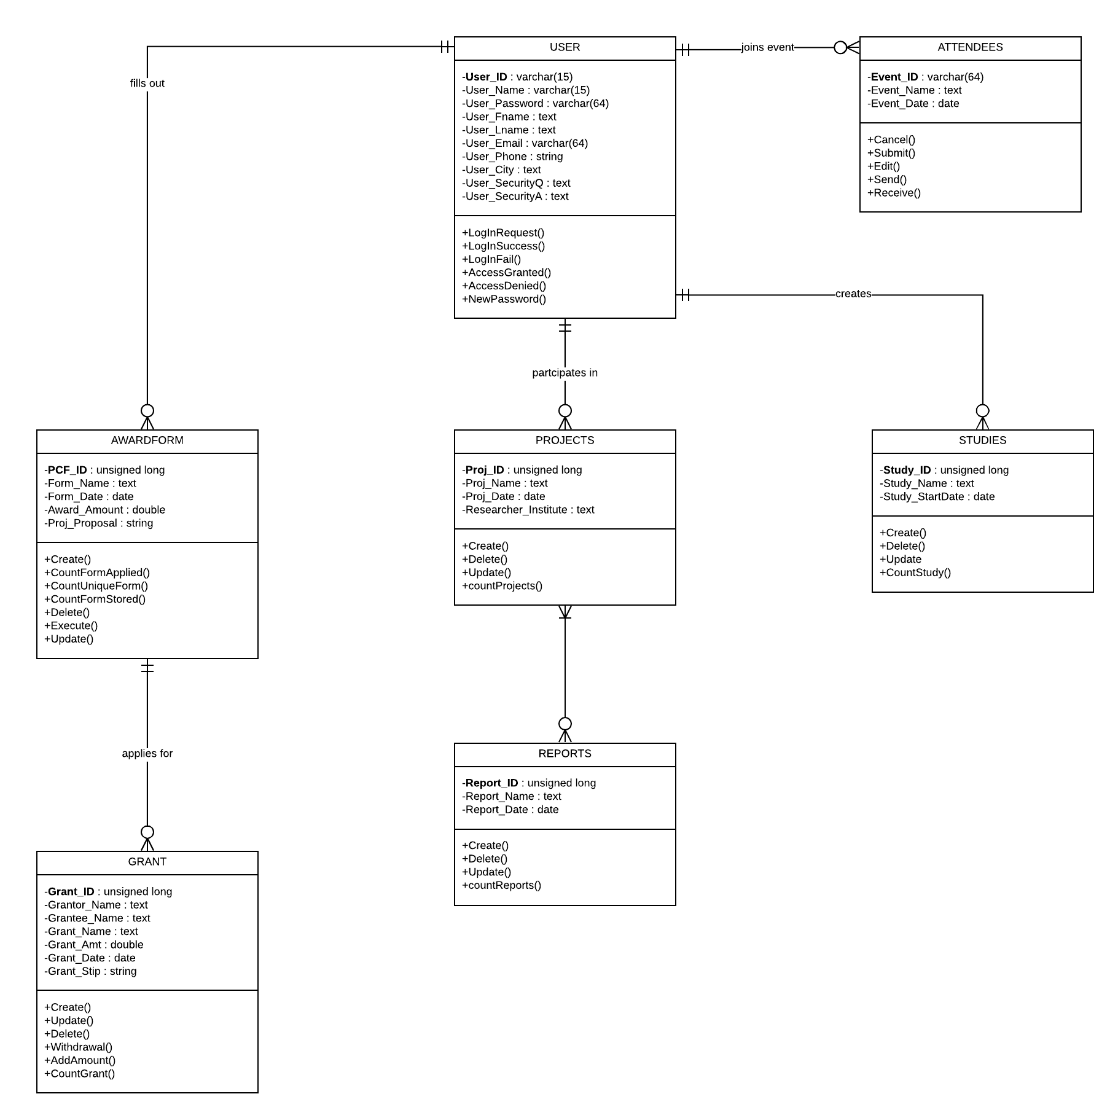

**Window Navigation**

**Screen Layout**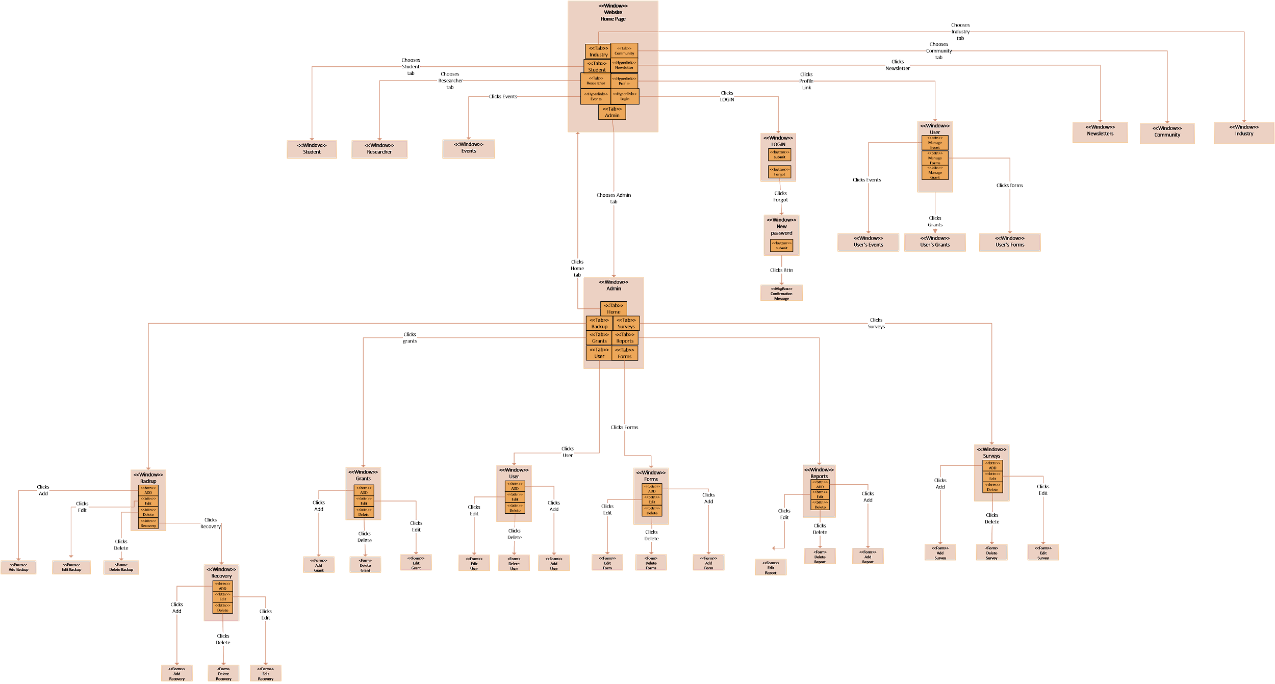

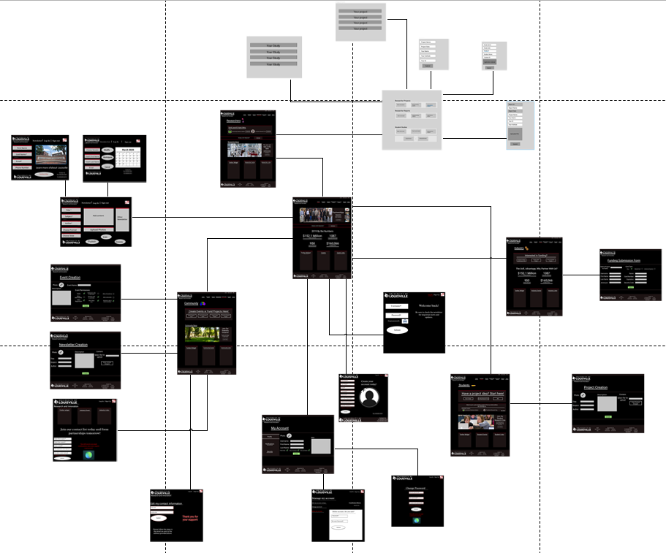

This Screen Layout Shows The main home page and every destination that the user can make from the main homepage. The screen layout shows each and every use case that is needed for the website to function as its own prototype. Use cases such as the login page, sign in page, Newsletter sign up, and every other use case are all realized into their own prototypes to show how they could look like, what the user will see and what they will need to enter into the text boxes to complete the main flow of the use cases we built in assignment 3. The screen layout is very important to show a basic map of the website and to show each and every use case as its own prototype.

**Gantt Chart**

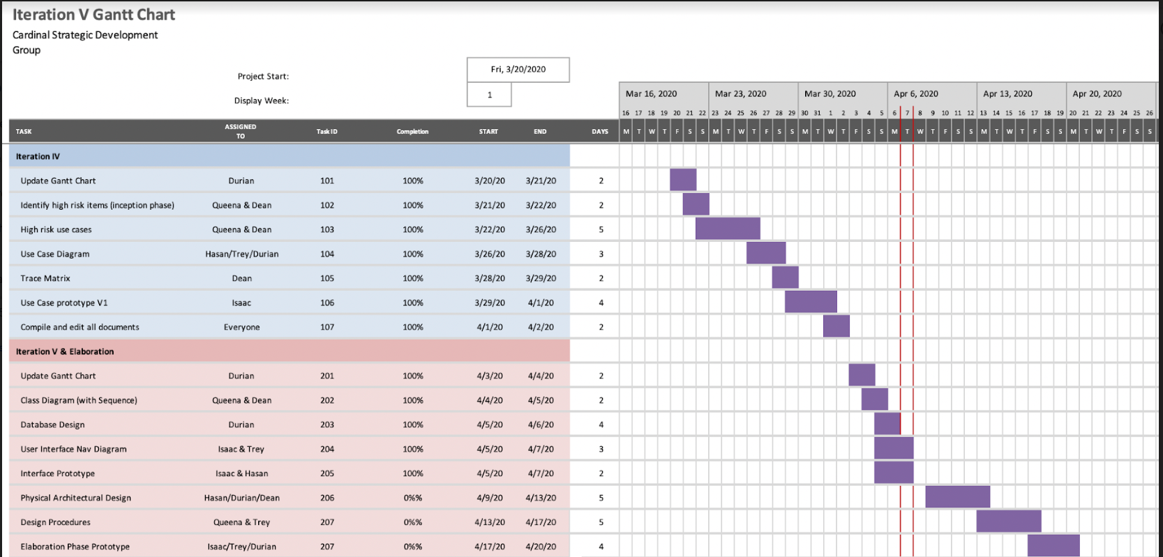

**Prototype**

Upon arriving at the front page in the top left the UofL logo and the text Research and innovation are displayed. A login, My Account and iRIS portal link are included at the very top. A simple NAV cluster is also included with a highlighted red bar indicating which page the user is on. Below this we have a slideshow of news images and text. The most important news will go here. Moving below this we have another small link to the iRIS portal which may be removed once it is phased out entirely. Below the portal link there is a section for statistics which will showcase UofL’s achievements in the latest year of research. This will serve as marketing to draw visitors in and make them more likely to work with us with funding. Below this we have 3 sections for a twitter news widget, events and quick links. This area can also be replaced with a plethora of other content ideas if need be, this is just an example of things that could potentially go here. Finally in the footer of the doc we have the UofL logo, login links, resource links and contact us information. This footer will remain standard on all pages of the site.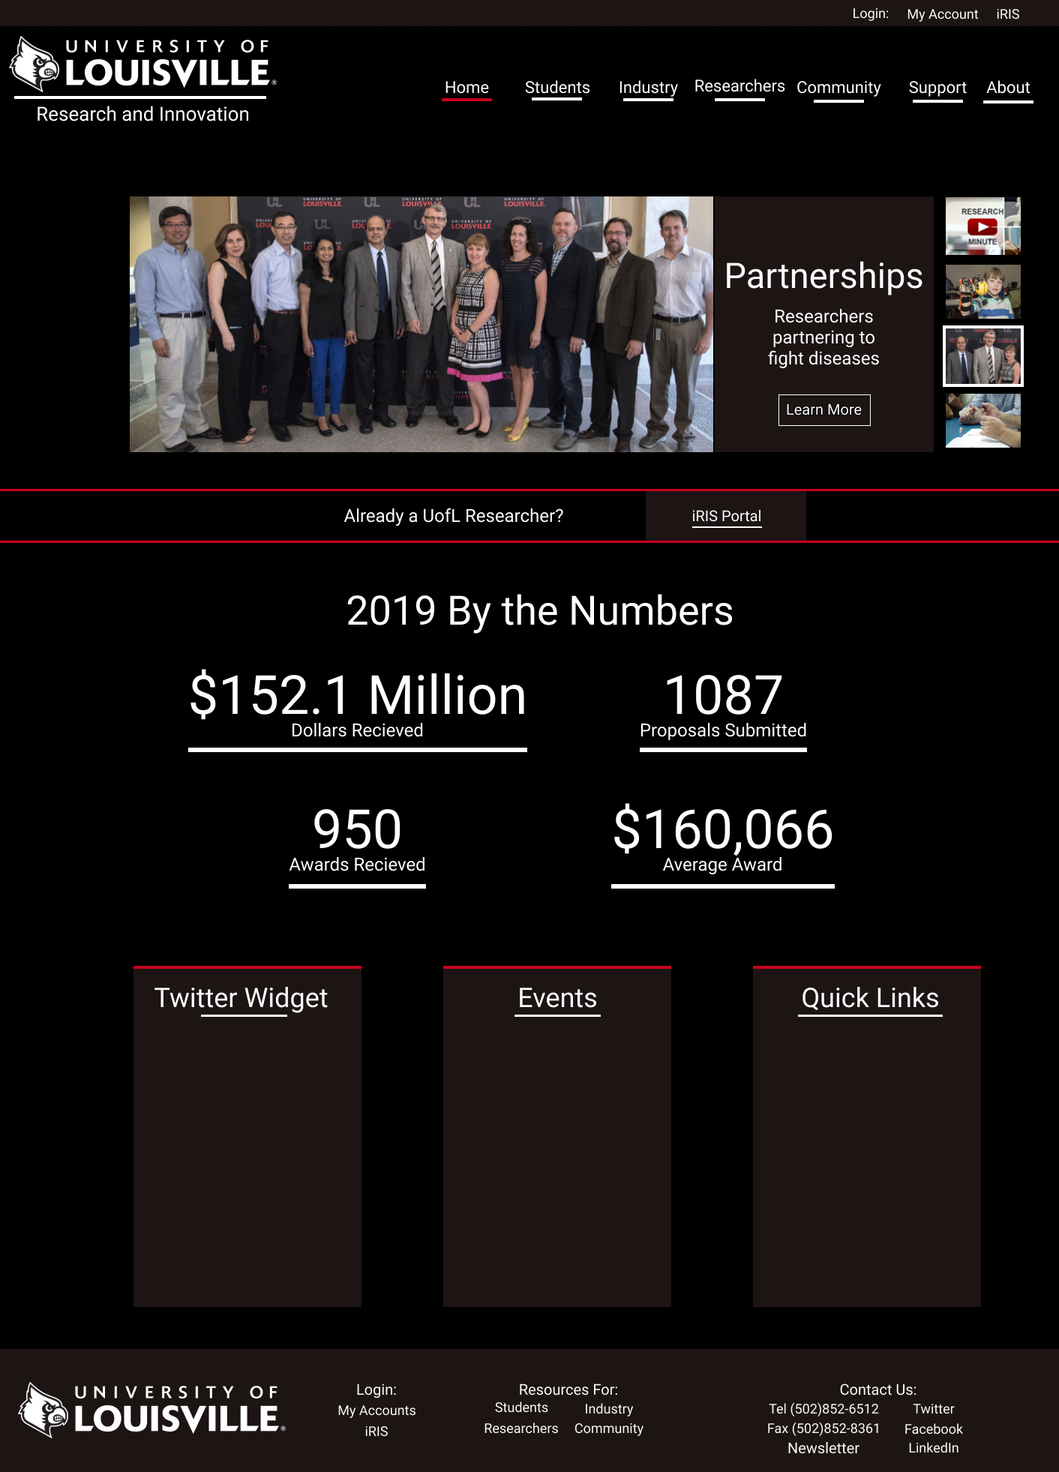

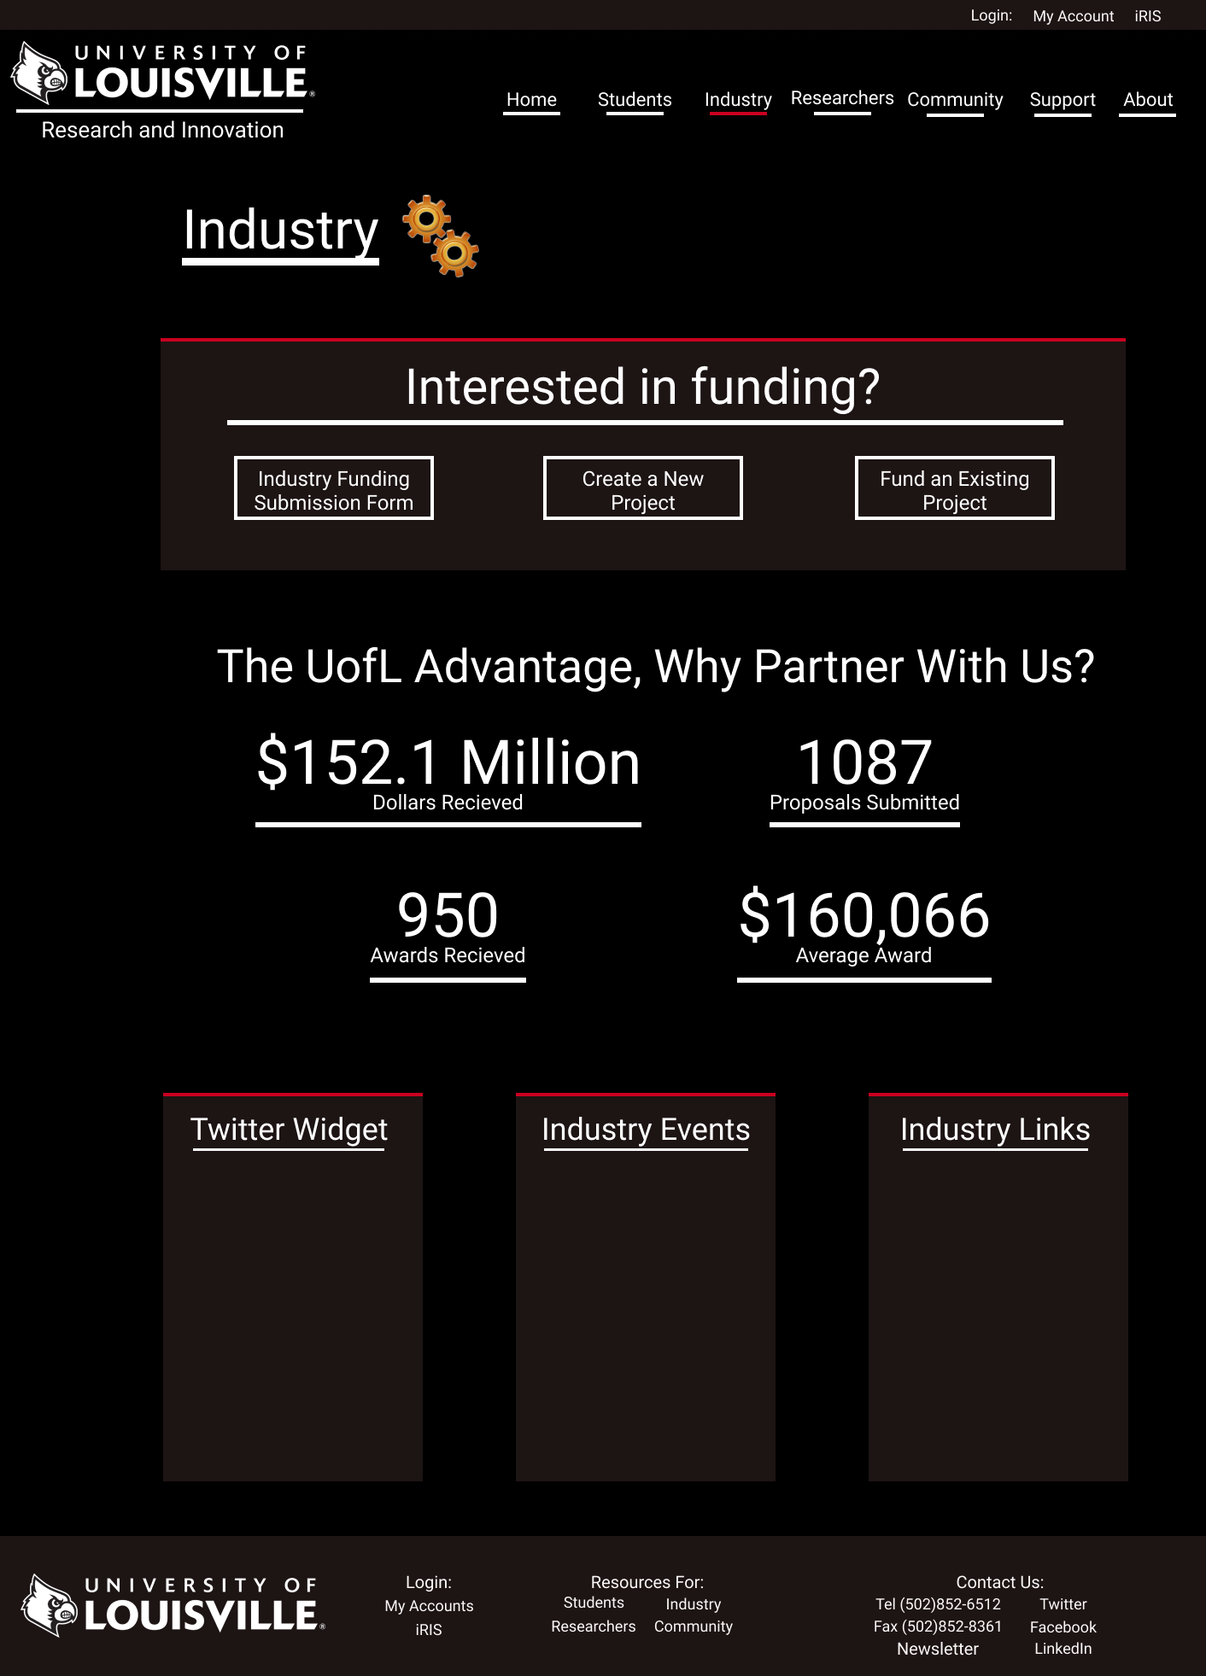

Upon arriving at the industry page, you are met with a distinctive icon indicating which page you are on. Industry members are then guided to the large text interesting in funding, where they can then choose from the submission form, creating a new project, or funding an existing project. After this visitors are drawn to a variety of statistics which will showcase UofL’s past successes with industry. We have placed statistics from the front page as placeholders. From there the all important twitter news widget will go at the bottom as well as any industry related events or important links.

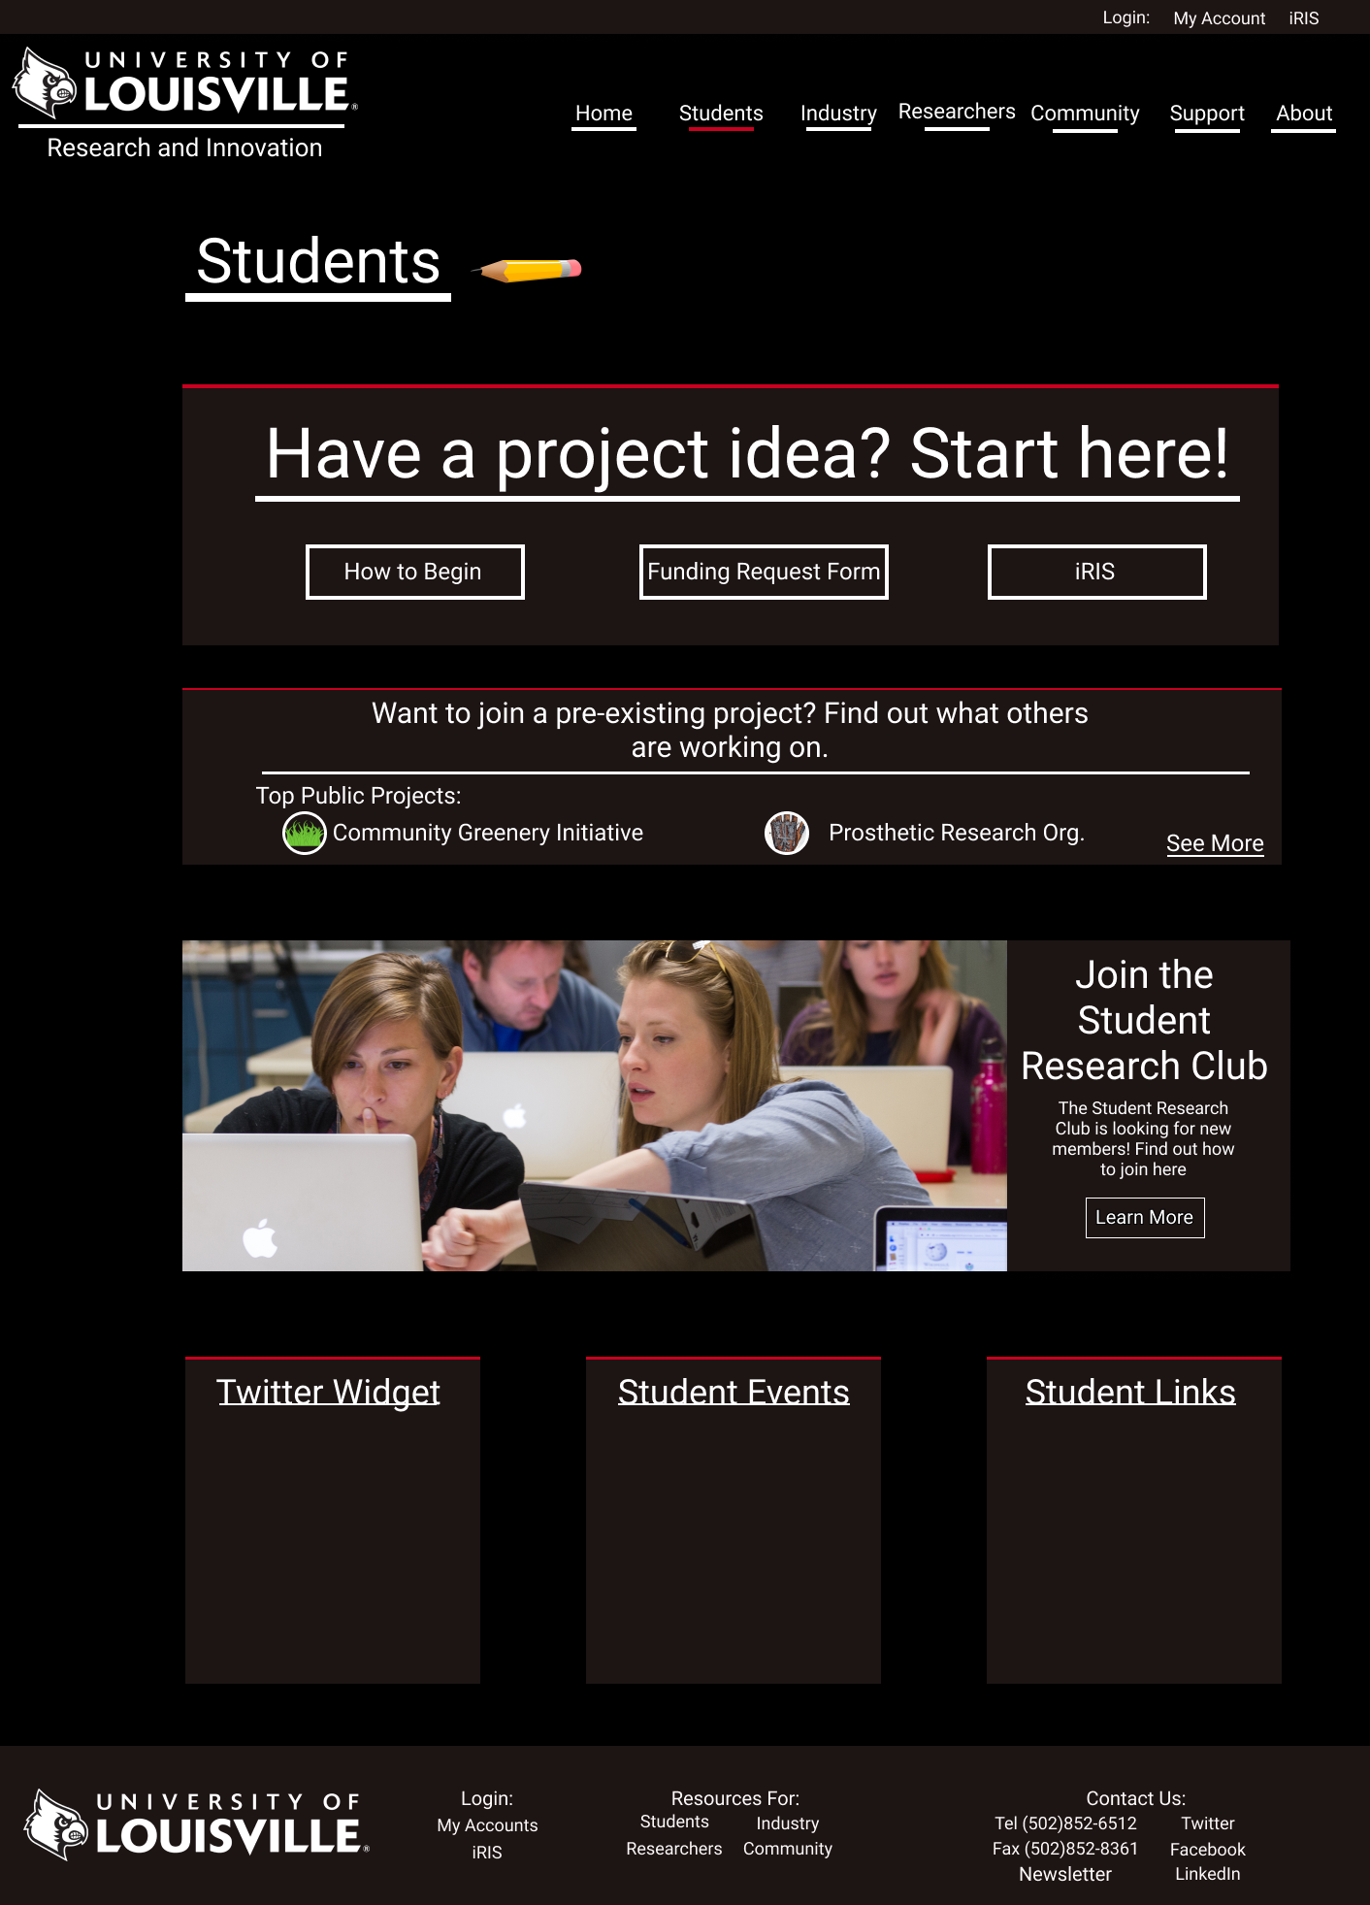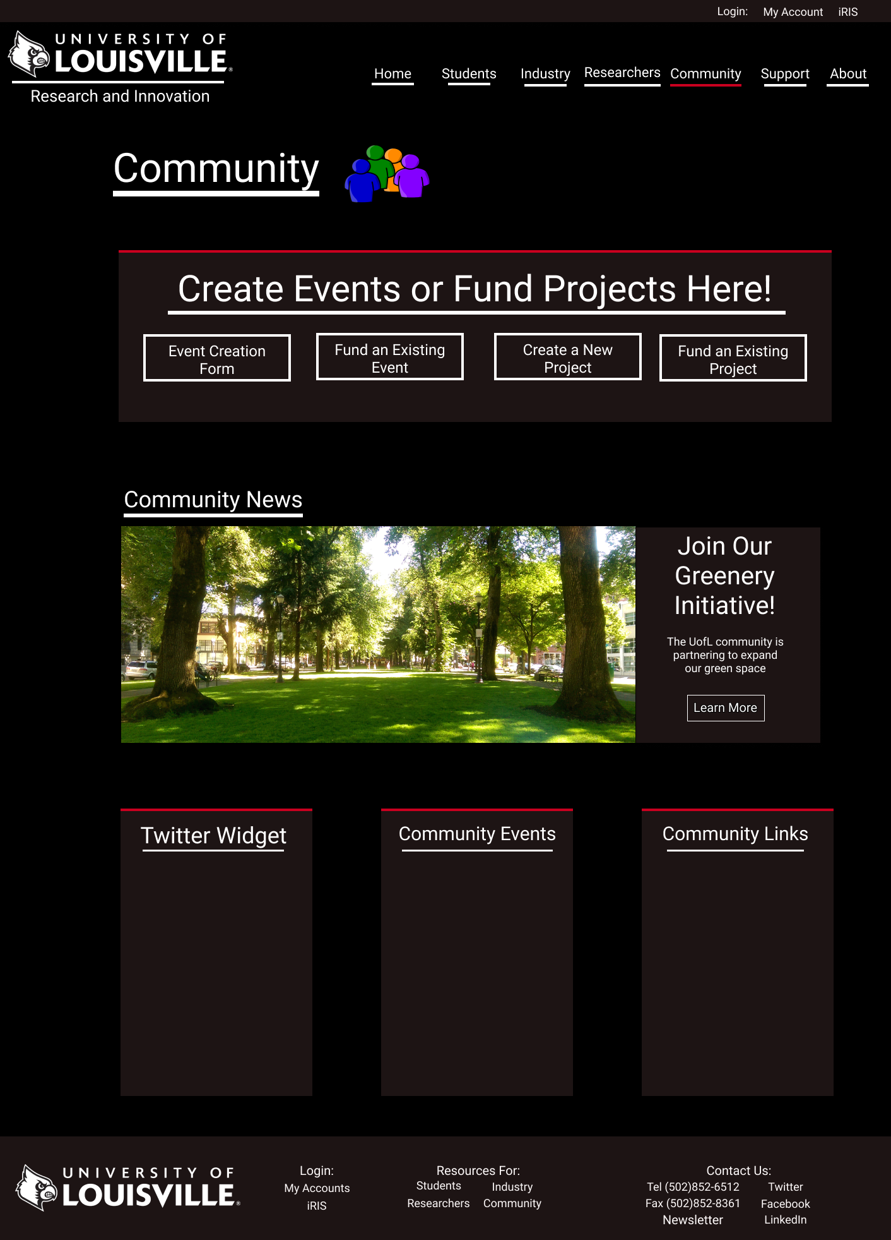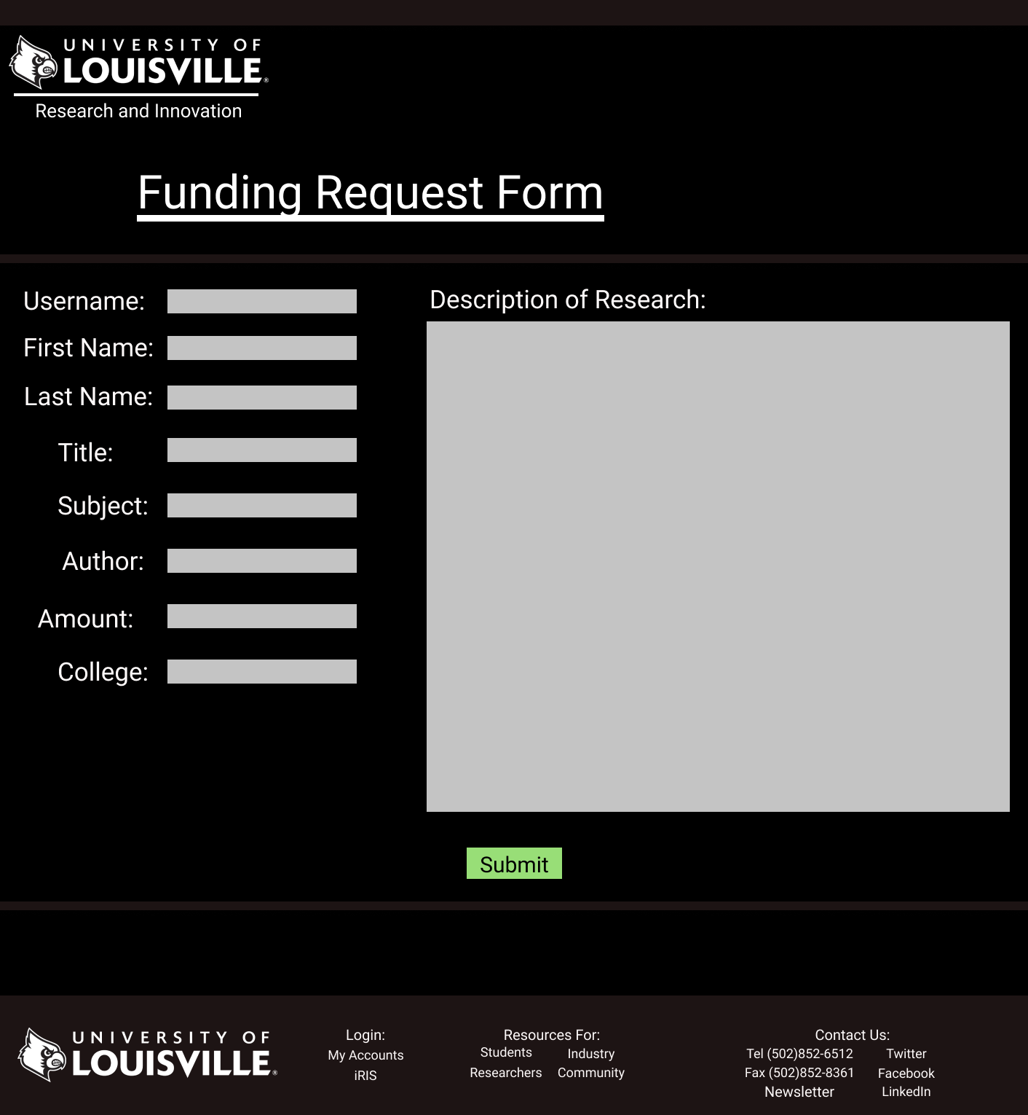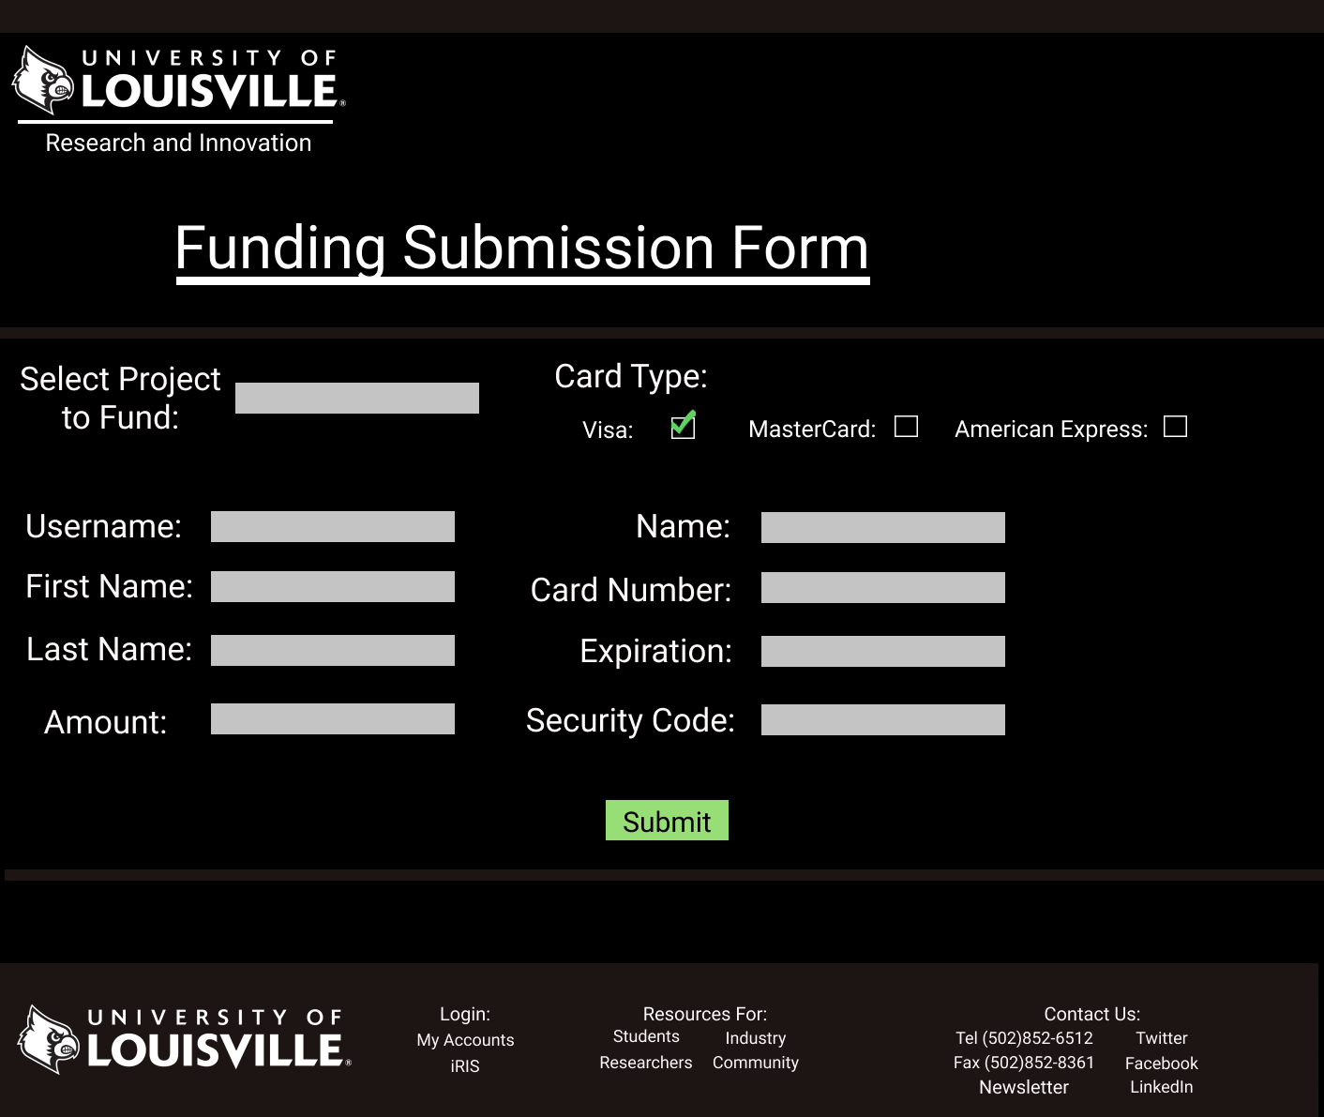

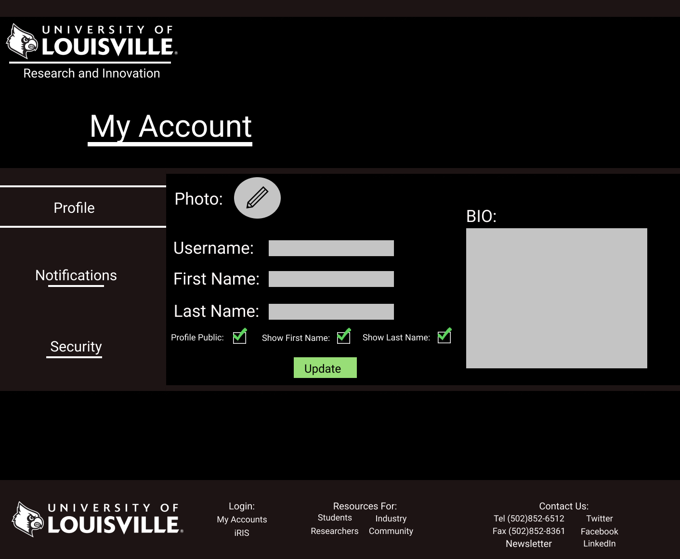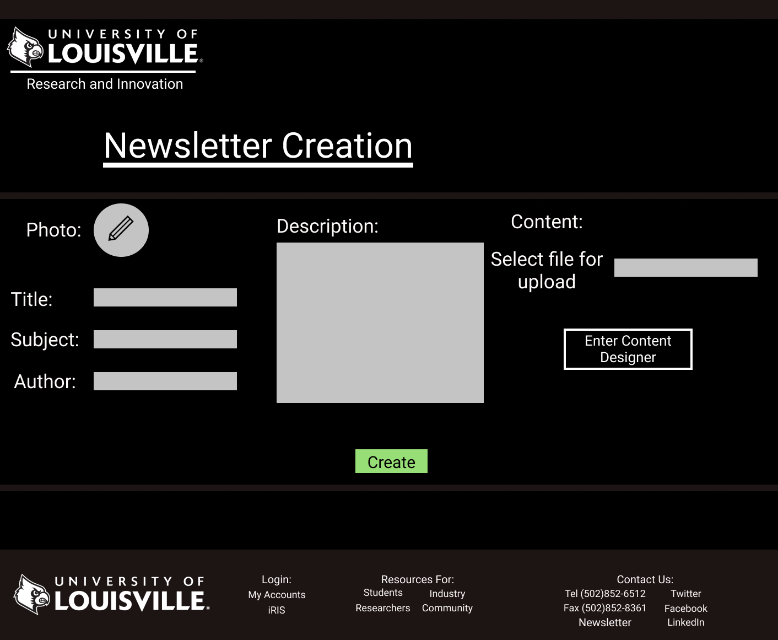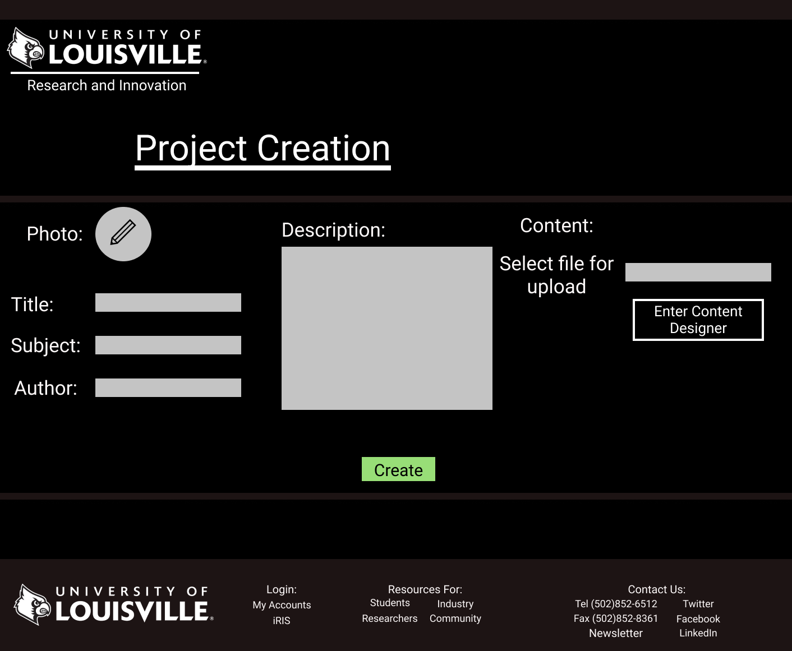

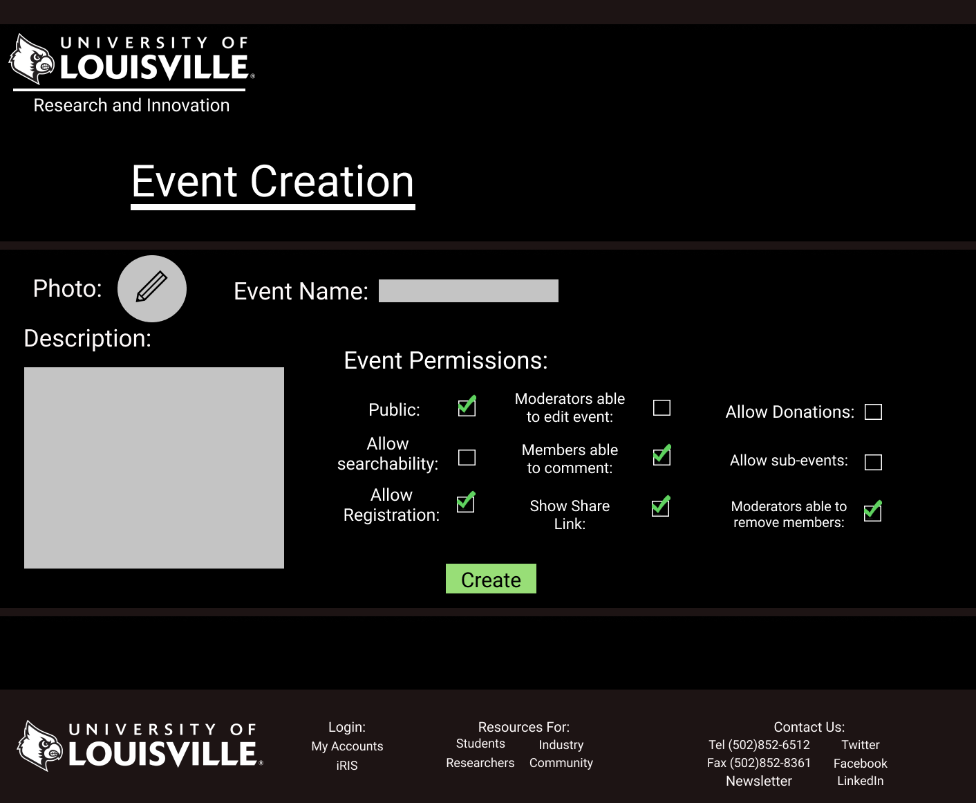

**Students Page**

Upon arriving at the student’s page, you are met with a distinctive icon indicating which page you are on. Students will be immediately greeted with large text guiding students who wish to create a project to the correct places, a tutorial on how to begin, a submission form, and the link to the iRIS portal. Students are also able to see what the most popular projects or events other students are working on which can be hosted by any student, researcher, community or industry leader. Moving below that we have included a student news section with the demo content, “Join the student research club.” The news section contains an image, a text description and a learn more button for those who are interested. Also included on the page would be the all-important twitter widget providing a live feed of news and any other content, links, and events could fit into the additional blocks.

**Industry**

Upon arriving at the industry page, you are met with a distinctive icon indicating which page you are on. Industry members are then guided to the large text interesting in funding, where they can then choose from the submission form, creating a new project, or funding an existing project. After this visitors are drawn to a variety of statistics which will showcase UofL’s past successes with industry. We have placed statistics from the front page as placeholders. From there the all important twitter news widget will go at the bottom as well as any industry related events or important links.

**Community**

Upon arriving at the Community site, visitors are met with a distinctive icon indicating that they are on the community page. From there community members are met with the large text asking them to create events or fund projects. An event creating form is available, as well as fund existing events, create new projects and fund existing projects. Moving down there will be a large section for community news with an image drawing visitors in and text explaining with a Learn More link at the bottom. We have placed a demo event inside this area called The Community Greenery Initiative. The bottom of the page like the rest will contain a twitter news feed, community related events and links.

**Researchers**

Upon arriving at the research page, visitors are met with a unique icon indicating which page they are on. From there we have a quick launch project menu so researchers can get back to their projects as fast as possible. This page uses the assumption that researchers will arrive here first before jumping to their project environment. Moving down we have a small section for the iRIS Portal which can be removed once it is phased out. Just like the community page we have also included a researcher news section with a text description and a learn more button. Example content has been inserted to demo what it would look like. Finally continuing with the uniform nature of the pages a twitter widget and Researcher links and events will also be added to the bottom section.

**Login Demo**

The login demo is the standard homepage with a simple box located at the top

**My Account**

A simple GUI where you can edit a photo, username, Fname, Lname, BIO. This will also contain notification settings and security settings.

**Event Creation**

A simple GUI that allows for the creation of an event with a photo, name, description and various permissions.

**Newsletter Creation**

A simple GUI that allows for the creation of a newsletter with a photo, title, subject, author, description and content upload.

**Project Creation**

A simple GUI that allows for the creation of a newsletter with a photo, title, subject, author, description and content upload.

**Funding request**

A simple GUI that allows for the submission of a funding request form with the inclusion of a username, Fname, Lname, Title, Subject, Author, Amount, college, and description of research.

**Funding Submission Form**

A simple GUI that allows for the submission of a funding submission form with dropdown to select a project, username, Fname, Lname, amount, card type, name on card, card number, expiration, and security code.

**Assignment 3 prototypes**

Create Event Registration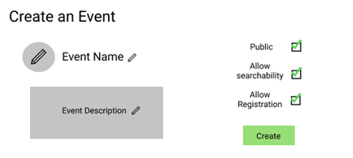

This diagram shows a prototype of the event creation wizard where the option to create/allow registration for the event will be initially housed. The event organizer will select the box for Allow Registration and then click create event, which will create the event and create the option.

Edit Event & Delete Registration

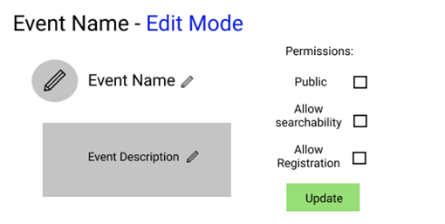

This prototype will allow for the editing and subsequent deletion of event registration. Both will be done from this screen in this conceptual prototype. The event organizer or one of its moderators can enter edit mode for their event where they can change registration permissions. Registration can be enabled or disabled here. This model showcases the event registration box now being unchecked thereby deleting the ability to register for the event. The other place registration would be deleted would be during event deletion

Create Security Measures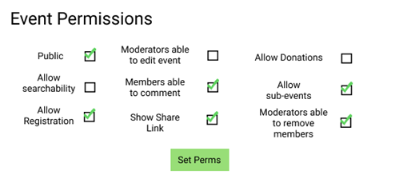

This prototype allows event organizers to choose from a list of security measures they can enable for their event. The creation of the security measures will be done during the event creation process and any subsequent changes will be made in permission edit mode.

Edit Security Measures & Delete Security Measures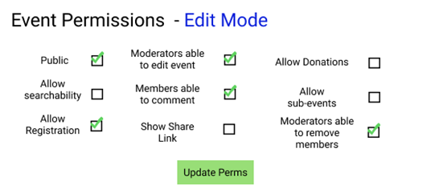

Editing & deletion of security measures will be done primarily from the event edit screen. The only other place security measures could be deleted would be on event deletion. The event organizer would click the edit permissions button and begin checking/unchecking boxes for permissions. The checking/unchecking would allow event organizers to edit security measures and at the same time the unchecking of boxes would be the deletion of delete security measures. Once permissions are edited/deleted as needed the organizer would hit the update button.

**Prototypes**

**Backup/Recovery**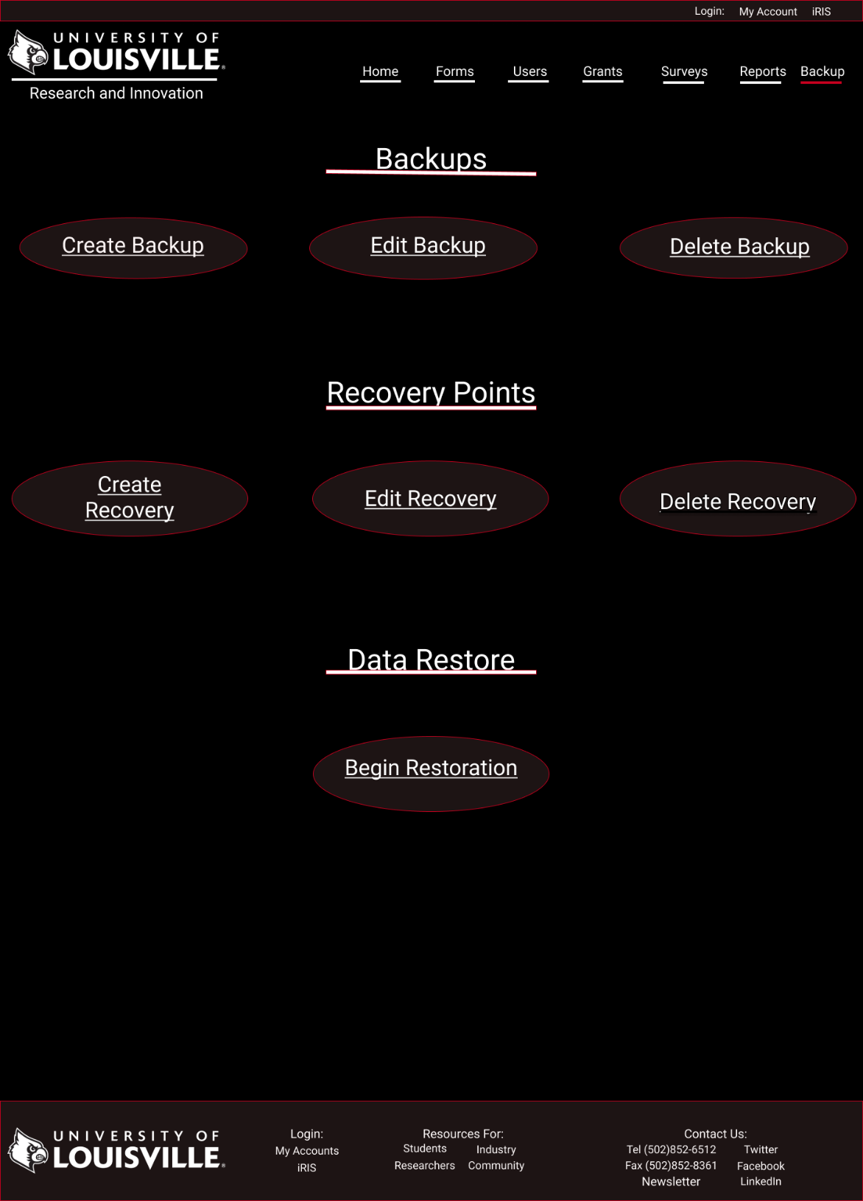

This prototype displays the backup and recovery management page. It is only accessible to administrator. Designed to allow for ease of access and speed. The admin will be able to access the is page by clicking on the backup tab at the top of the page. The page will give the admin the ability to create, edit or delete backup and recovery files. It will also allow the admin to initiate data restoration from the page. In effort to add another layer of security the admin will have to reenter their login and password in order in access any of windows forms associated with the links displayed. The design incorporates dark and clean theme inline overall innovative look.

**Prototypes**

**Grant**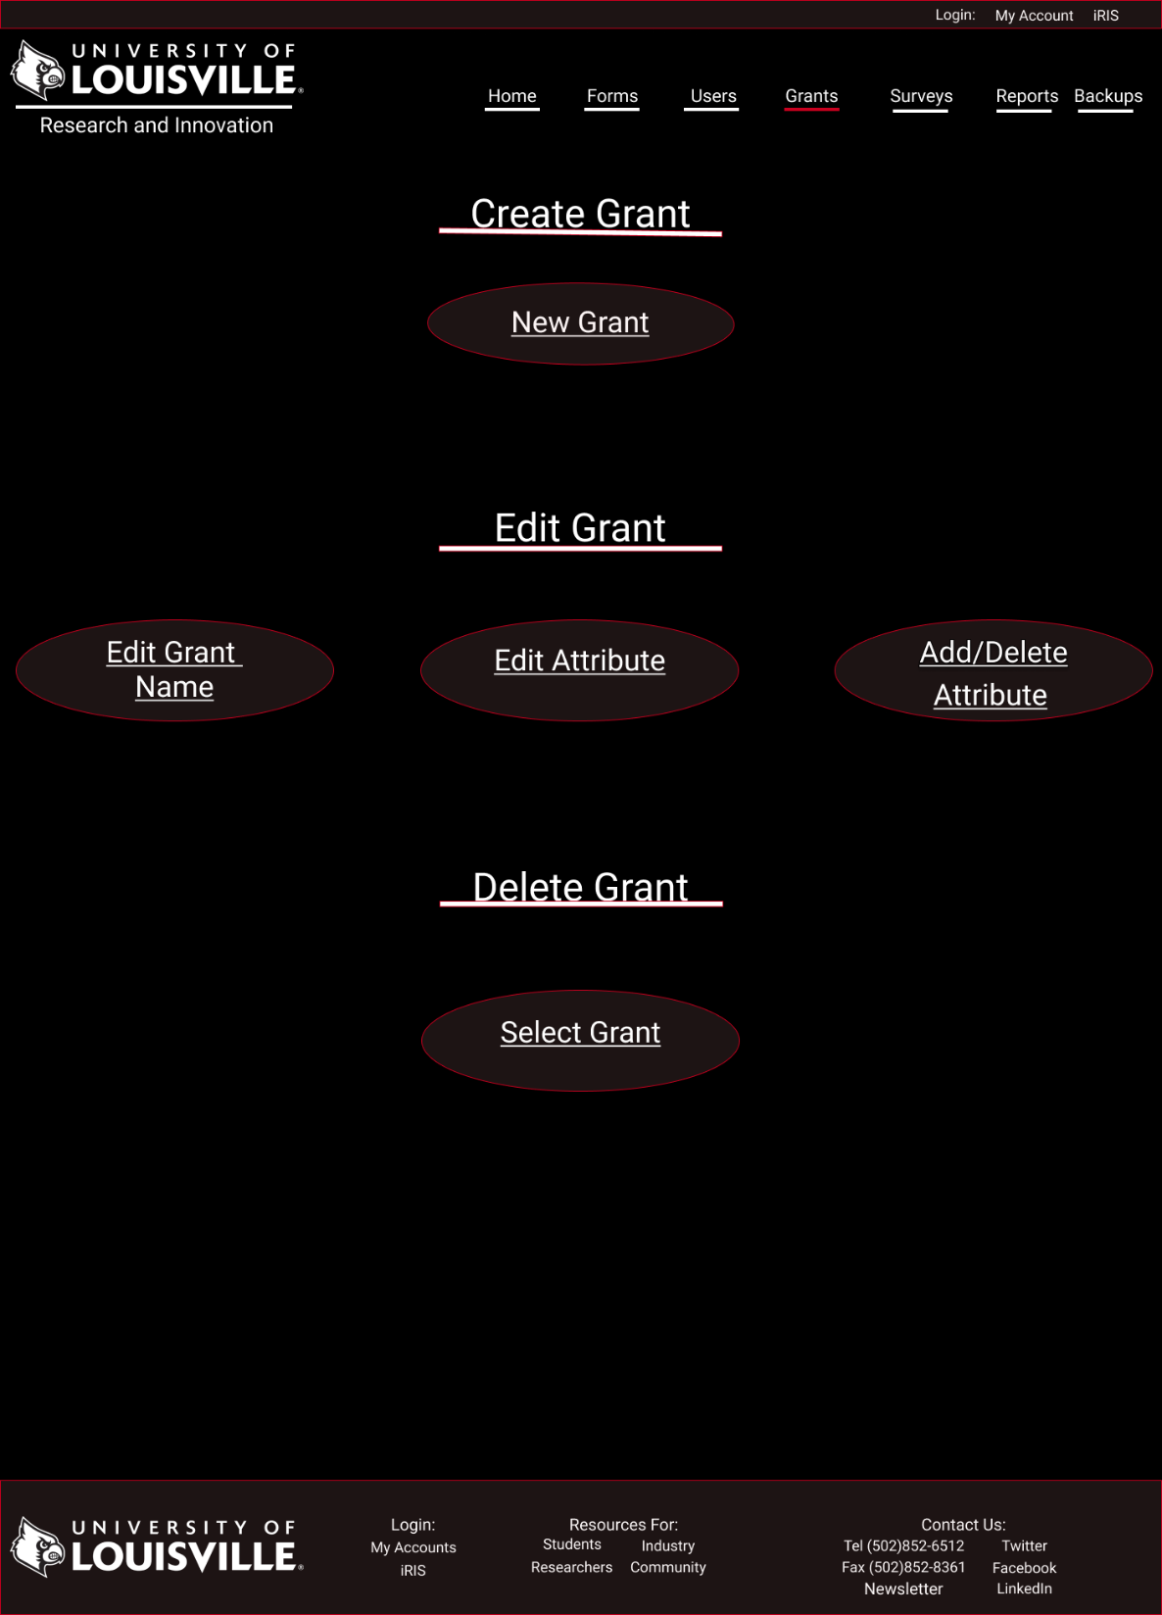

This prototype displays grant management page. It is only accessible to administrator. Designed to allow for ease of access and speed. The admin will be able to access the is page by clicking on the grant tab at the top of the page. The page will give the admin the ability to create, edit or delete grant objects. In effort to add another layer of security the admin will have to reenter their login and password in order in access any of windows forms associated with the links displayed. The design incorporates dark and clean theme inline overall innovative look.

**Prototypes**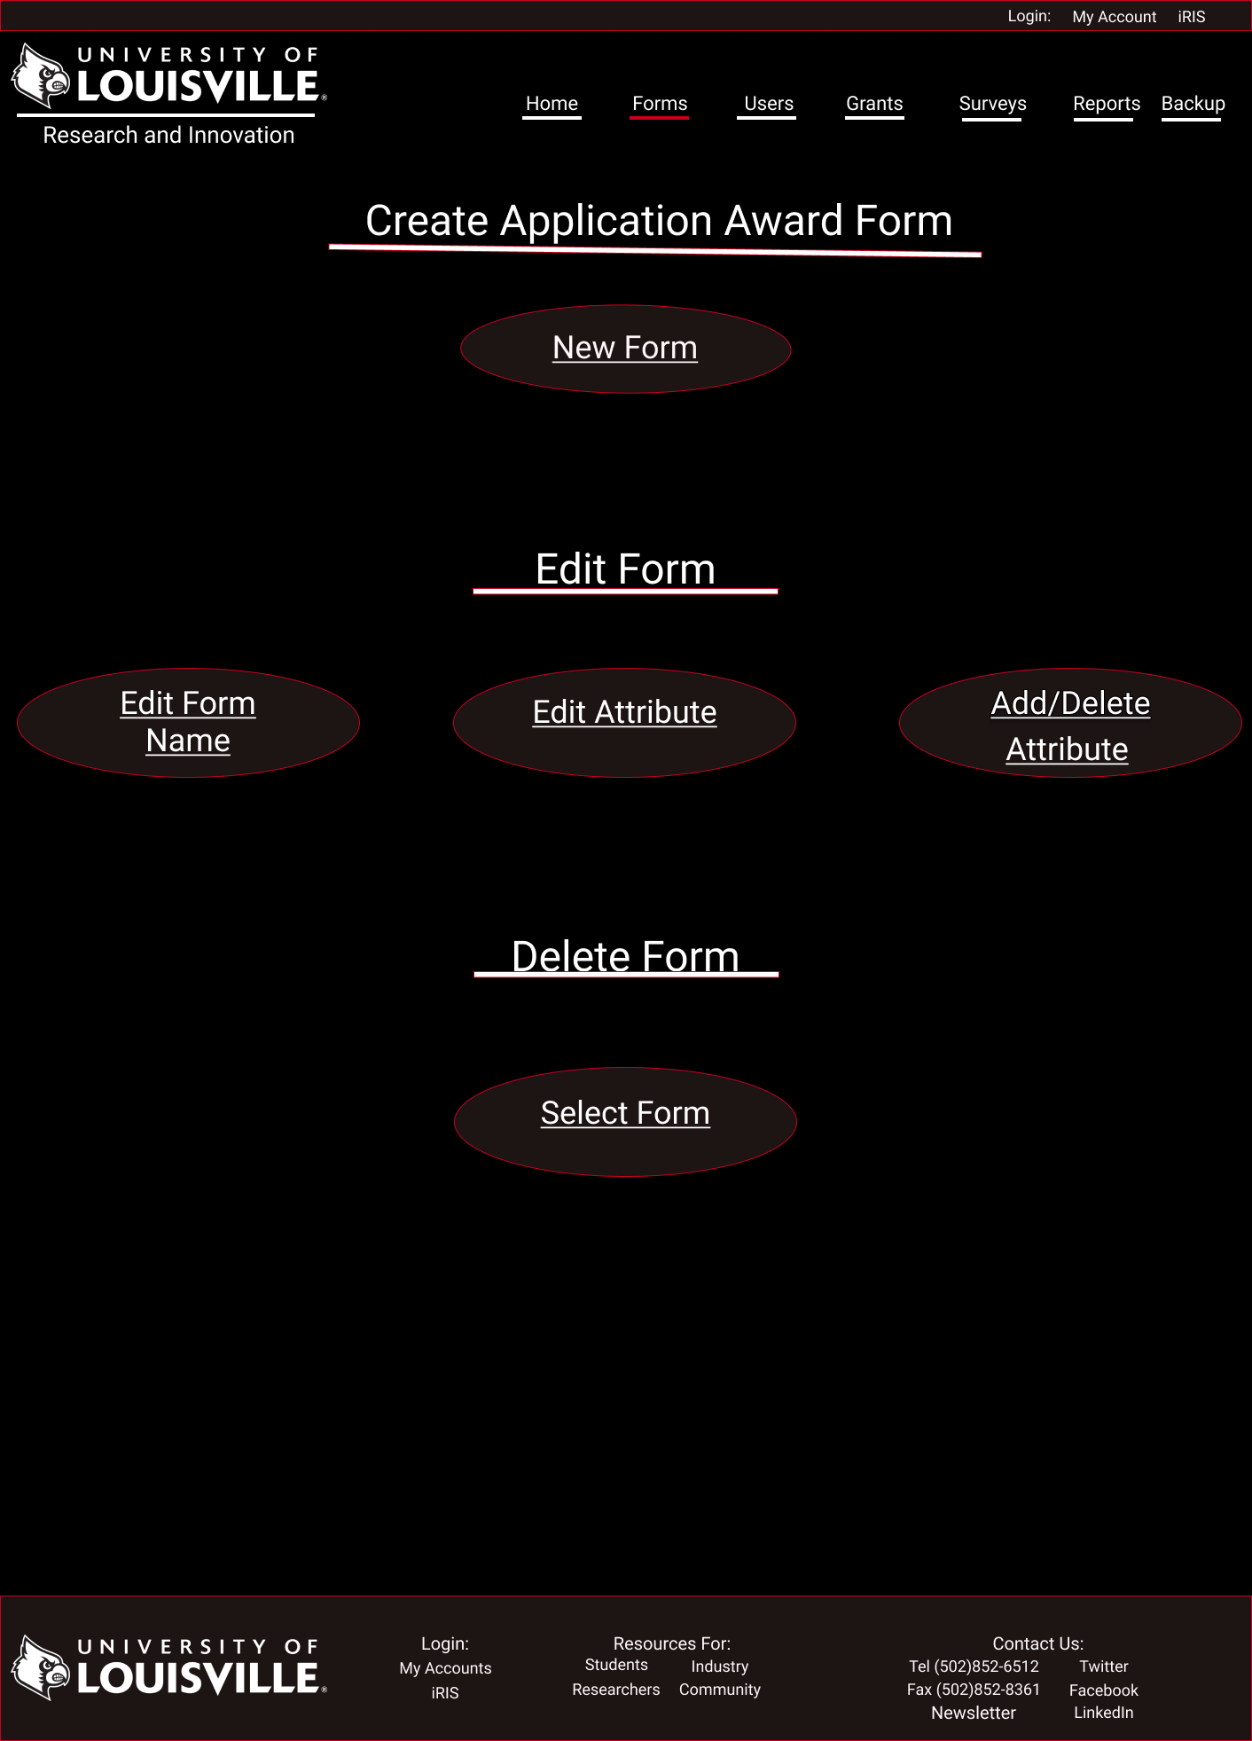

**Application Award Form**

This prototype displays application award form page. It is only accessible to administrator. Designed to allow for ease of access and speed. The admin will be able to access the is page by clicking on the forms tab at the top of the page and selecting link associated with awards form page on main form landing page. It will also be accessible via submenu when mouse hovers over the form tab. The page will give

**Prototype**  
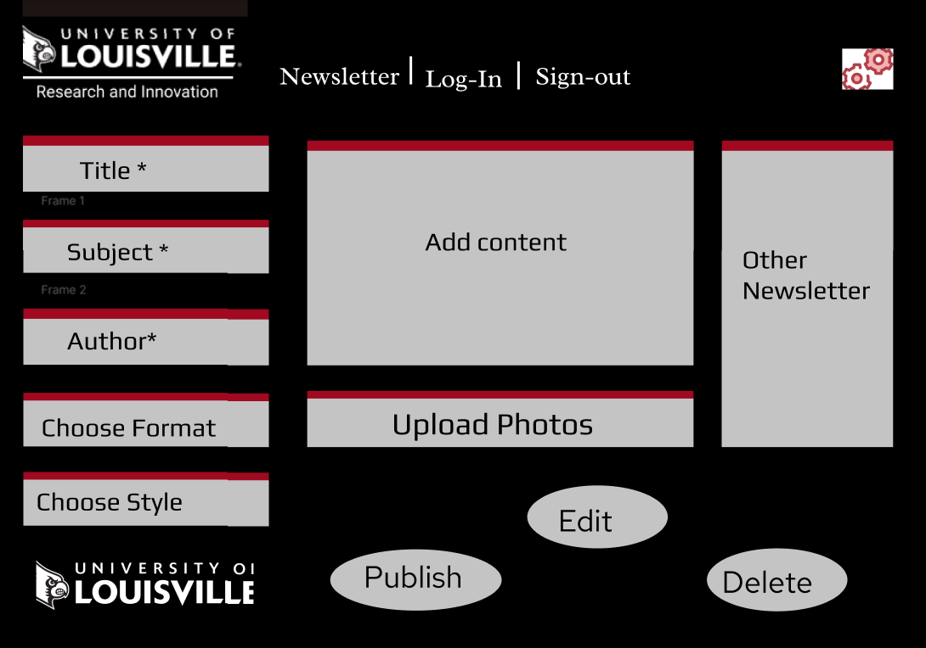

Upon arriving at this Newsletter page, the user must be logged in as administrator in order to obtain authority for creating and having access to Newsletter. After logging, the user must insert title, subject, author, and content of the article. It is given an option for the user to implement and chose different format and styles to produce a good visual. There will also be an option to upload photos and images. There is the University of Louisville for the Research and Innovation Office logo presented in the top of the page and the bottom of the page.

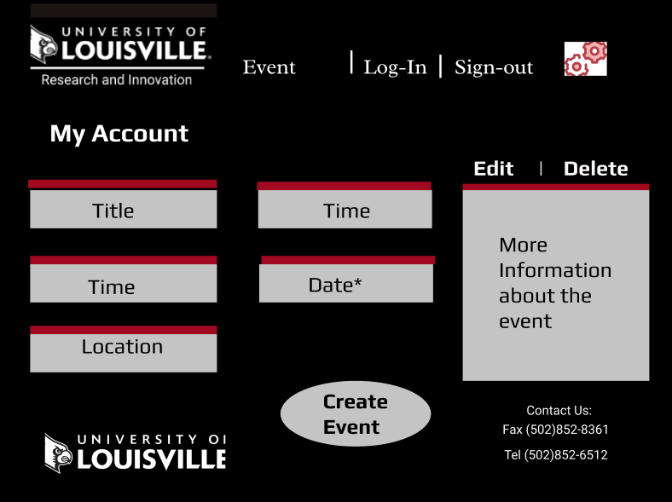

Upon arriving in the event page, the users ate presented to insert information to schedule an event on campus. It is required that the user login as an administrator to manages information that is given to them by other stakeholder. The user will need to insert information on title, time, date, location, and detail information of the event. After inserting all the necessary information, the user is then able to create and publish the event. There is given an edit and delete to give the user the option to modify the events.

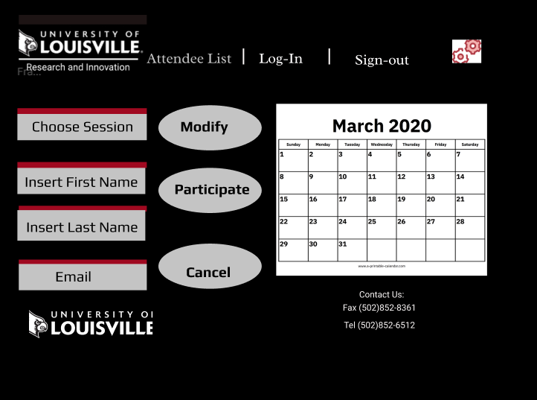

This attendee list prototype is meant to allow all the stakeholders to join and attend a particular event. The user must choose the session that they want to attend, insert their first name, last name, and email address. Once they insert their information, they are must select participate in order for their names to be joined in the attendee list. If the user changes their mind, their can also remove or change information by logging in to the page.

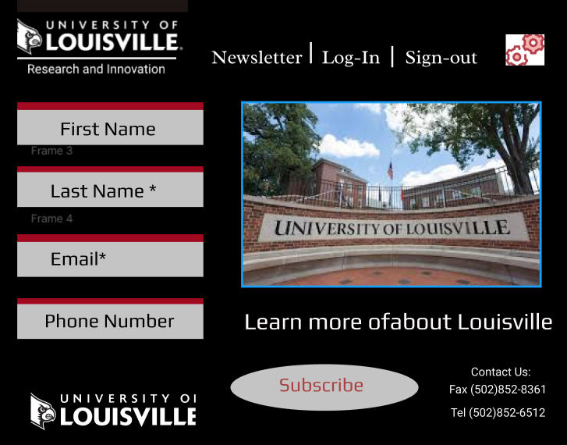

We continue to use black, red, and white as the color theme of the prototype because that presents the University of Louisville. The Research and Innovation logo is present to should that this website is specific to their department. As the user prompt to subscribe to newsletter, they must insert information such as first name, last name, email, and phone number.